**Installation Guide for Virtual Machine and accompanying GUI**

This is a guide to help install the necessary software required to use the Virtual Machine (VM) and an accompanying Graphical User Interface (GUI). The Virtual Machine is contained in the folder ‘VMSimulator’ which should exits where you found this document. Also in the directory is the code for a GUI that will set up and run the Virtual Machine. This Guide will split up into 2 main sections. The first will show you how to set up the VM and the second will instruct you on setting up what is necessary for the GUI.

**1. Setting up the Virtual Machine**

**Download Oracle**

To Download Oracle VM Virtual Box is software that helps run and manage virtual machines that are on your computer. Since our VM is contained in a Virtual Machine (Linux Mint 15.x) and the GUI uses certain Oracle functions we need this piece of software. Download it with this link:

<http://download.virtualbox.org/virtualbox/5.1.4/VirtualBox-5.1.4-110228-Win.exe>

Once downloaded and set up you will also need an extension. Download it with this link:

<http://download.virtualbox.org/virtualbox/5.1.4/Oracle_VM_VirtualBox_Extension_Pack-5.1.4-110228.vbox-extpack>

Now if you double click on the file ‘VM SETUP\VMsimulator\VMSimulator.vbox’ the VM should run, however we haven’t got everything completely setup right. We still need to correctly set up the network connection between your computer and the VM, so look at the next section for detail on how to do that.

**Make sure virtualisation is enabled on your BIOS**

In the VirtualBox Manager (see below) go to Preferences > General, and check the OS type. It should be “Ubuntu (64-bit)”. If no 64-bit options appear, then virtualisation is not enabled in your BIOS. Restart your PC, go into the BIOS settings (F2 or F12 usually), and enable it.

**Set up Network**

When running Oracle VM VirtualBox Manager got to File->Preferences and select Network (left hand side). Choose the tab ‘Host-only Networks’. Select ‘Virtual Box Host-Only Ethernet Adapter’ and click on the little screwdriver on the right to edit it.

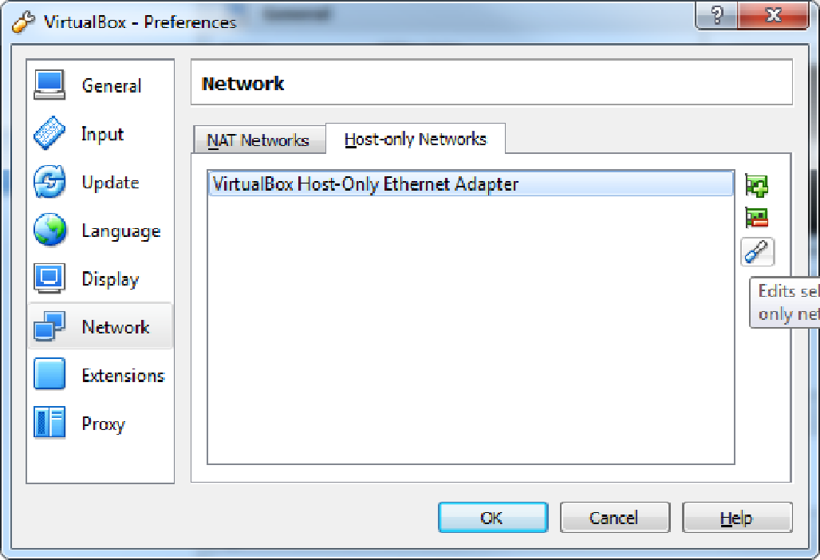

Change the details to the ones given below in the figures.

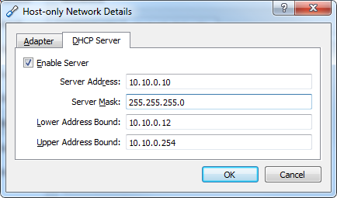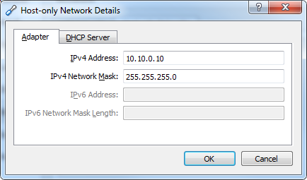

Mac Address? Test with Alex

**Path Variable Setup**

To ensure we have some needed commandline feature from Oracle, add the following directory to the path environment variables.

->Click on the windows home button

->Right-click ‘Computer’ and select ‘Properties’

->On the left hand side select ‘Advanced system settings’

->Now choose the button ‘Environment Variables…’

-> In the top box add the following variable with its value:

Variable Value

PATH C:\Program Files\Oracle\VirtualBox;

**Setting new MAC Addresses**

In Oracle Manager and go to the settings of your VM.

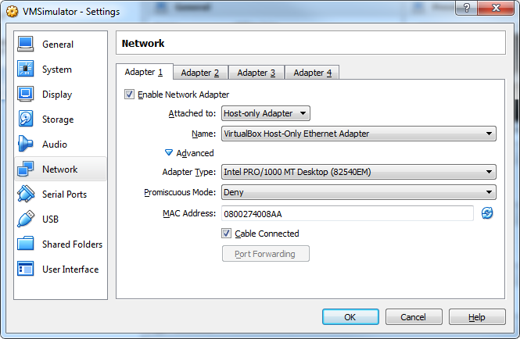

Use the refresh button to the right of the MAC Address to create a new one. Make sure you do this while your VM is **not** running. Once done, Re-run your VM, go to ‘Network Settings’ and find out your VM IP Address (should be 10.10.0.xx). Now you know your IP you can set the accompanying GUI to look on the right network. Go to ‘mainApp.py’ and change line 3 accordingly.

**2. Requirement for the GUI**

The following are requirements to run the GUI. When fully set up the GUI can be run by running the ‘mainApp.py’ python script.

**Python 2.7.11**

The first thing to do is to get Python up and running. Download Python 2.7.11 using this link: <https://www.python.org/downloads/release/python-2711/>

You want the ‘**Windows x86 MSI Installer**’ version. Run the .msi you’ve just downloaded and follow the installation process. This installation also includes ‘pip’ which is software that will help you install the other libraries.

**PyQt4**

For PyQt4 go to

<https://www.riverbankcomputing.com/software/pyqt/download>

You want the ‘[**PyQt4-4.11.4-gpl-Py2.7-Qt4.8.7-x32.exe**](http://sourceforge.net/projects/pyqt/files/PyQt4/PyQt-4.11.4/PyQt4-4.11.4-gpl-Py2.7-Qt4.8.7-x32.exe)’. When installing, make sure to put it the C:\Python27 folder.

**pyqtgraph**

Now download pyqtgraph from

<http://www.pyqtgraph.org/>

and select the ‘**pyqtgraph-0.9.10.win32.exe**’ option and go through installation process.

**pyepics**

In the command line install pyepics using pip.

‘pip install pyepics’

**3. GUI Designer**

A handy hint to create you our GUIs is to use ‘QtDesigner’ to create the layout. This involves downloading Qt 4.8.5. from:

<https://download.qt.io/archive/qt/4.8/4.8.5/qt-win-opensource-4.8.5-mingw.exe>

Once installed, you can use the ‘Designer’ software to create a GUI. Any questions don’t hesitate to ask Tim Price.

When you’ve created a GUI you can convert it into python code using ‘pyuic4.bat’ This will be somewhere on your computer from downloading PyQt4. To convert your code use the following command in the command line in the directory of the .ui project file created by ‘Designer’:

**C:\the\Directory\Where\the\File\is\pyuic4.bat –x projectname.ui –o nameofpython.py**

You can no import this into a python script and use it as a layout for your application